 | 12.1.45 Editors - Geometry Nodes Editor - Header - Add Menu - Utilities - Text
Table of content
Detailed table of content 1
Add menu - Utilities - Text 4
Format String 4
Join Strings 4
Match Strings 5
Replace Strings 5
Slice String 6
Find in String 6
String length 7
String to Curves 7
String to Value 9
Value to String 10
Special Character 10

Detailed table of content
Detailed table of content
Detailed table of content 1
Add menu - Utilities - Text 4
Format String 4
Inputs 4
Strings 4
Properties 4
String 4
Output 4
String 4
Join Strings 4
Inputs 4
Delimiter 4
Strings 5
Output 5
String 5
Match Strings 5
Inputs 5
String 5
Key 5
Properties 5
Operation 5
Output 5
Result 5
Replace Strings 5
Inputs 5
String 5
Find 5
Replace 6
Output 6
String 6
Slice String 6
Inputs 6
String 6
Position 6
Length 6
Outputs 6
String 6
Find in String 6
Inputs 6
String 6
Search 6
Outputs 7
First Found 7
Count 7
String length 7
Inputs 7
String 7
Outputs 7
Length 7
String to Curves 7
Inputs 7
String 7
Size 7
Character Spacing 7
Word Spacing 7
Line Spacing 8
Max Width 8
Properties 8
Font property 8
Font browser 8
Font Edit Box 8
Number of Users 8
Fake User 8
Open Font 8
Remove 8
Overflow 8
Align X 8
Align Y 9
Pivot Point 9
Output 9
Curve Instances 9
Line 9
Pivot Point 9
String to Value 9
Inputs 9
String 9
Properties 9
Data Type 9
Outputs 10
Value 10
Length 10
Value to String 10
Inputs 10
Value 10
Decimals 10
Properties 10
Data Type 10
Outputs 10
String 10
Special Character 10
Outputs 10
Line Break 10
Tab 10

Add menu - Utilities - Text
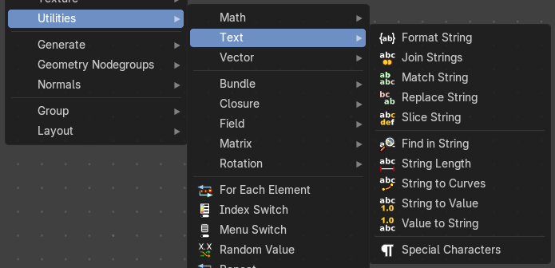
Text object related nodes.

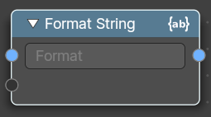
Format String
Insert Values into a string using a Python and path template compatible formatting syntax.
The syntax can be found here: https://docs.python.org/3/library/string.html#format-string-syntax

Inputs

Strings
The strings that you want to modify.

Properties

String
The python syntax to modify the string.

Output

String
The output string.

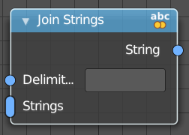
Join Strings
Allows you to join several string into a text string.

Inputs

Delimiter
Add a delimiter character.

Strings
The strings that you want to join into one text string.

Output

String
The output string.

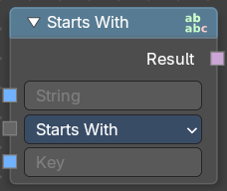
Match Strings
Allows you to compare strings to match conditions

Inputs

String
The input string.

Key
An input key.

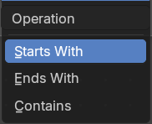
Properties

Operation
What string condition to match.

Output

Result
The output strings that matches the condition.

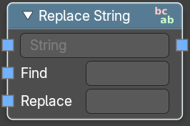
Replace Strings
Find and replace strings inside of the input string.

Inputs

String
The input string.

Find
The string part that you want to replace.

Replace
The string part that you use to replace the selected string part.

Output

String
The strings that you want to join into one text string.

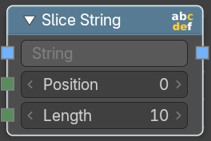
Slice String
Allows you to extract a string from a substring at given position with given length.

Inputs

String
The source string.

Position
The start position of the sub string.

Length
The length of the substring.

Outputs

String
The output substring.

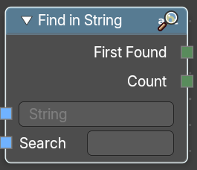
Find in String
Returns an integer of the total count of matching strings or the first integer position of a matching string

Inputs

String
The string that you want to search in.

Search
The string that would be matched in the string search.

Outputs

First Found
Returns the integer position of the first character of the found string.

Count
Returns an integer position of the first character of the found string.

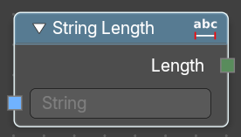
String length
Gives back the number of characters in this string.

Inputs

String
The string that you want to calculate.

Outputs

Length
How many characters the string has.

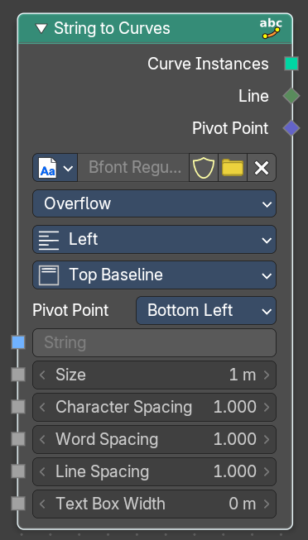
String to Curves
Converts the letters of a text into curve objects.

Inputs

String
The text string to convert.

Size
Size of the string.

Character Spacing
The character spacing of the string.

Word Spacing
The word spacing of the string.

Line Spacing
The line spacing of the string.

Max Width
The maximum width of the string.

Properties


Font property

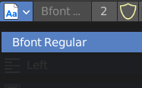
Font browser
A list of the loaded fonts.

Font Edit Box
The active font.

Number of Users
The number of users for this font.

Fake User
Keep this font in the blender file even when it has no users. The default font is special in this regards. It will not vanish when you close the file, even when it has no fake user assigned.

Open Font
Load a system font.

Remove
Removes the active font. The default font is special in this regards. You cannot delete it.

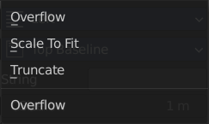
Overflow
The overflow method for the text.

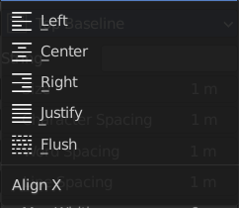

Align X
How to align the text horizontally

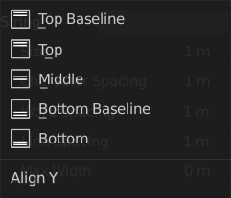
Align Y
How to align the text vertically.

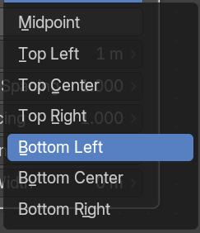
Pivot Point
What point of the string to use as the pivot point.

Output

Curve Instances
The curves output.

Line
Outputs the line number of the character.

Pivot Point
Outputs the selected pivot point position per character.

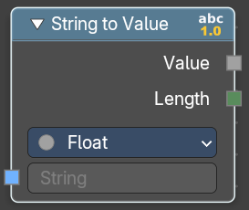
String to Value
Converts a string input (e.g. "3.14" or "42") into a numeric value that can be used in fields, modifiers, or procedural logic. It also outputs the length of the string for additional control or validation.

Inputs

String
The input string.

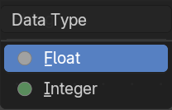
Properties

Data Type
Specifies the target data type for conversion

Outputs

Value
The output value.

Length
The number of characters in the input string as an Integer.

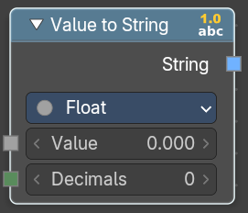
Value to String
Converts a value to a string.

Inputs

Value
The input value.

Decimals
How many decimals the value has.

Properties

Data Type
Specifies the target data type for conversion

Outputs

String
The output string.

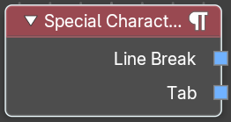
Special Character
Adds special characters to the text string.

Outputs

Line Break
Adds a Line Break to the text string.

Tab
Adds a tab to the text string.

